DATE: 31.01.2020
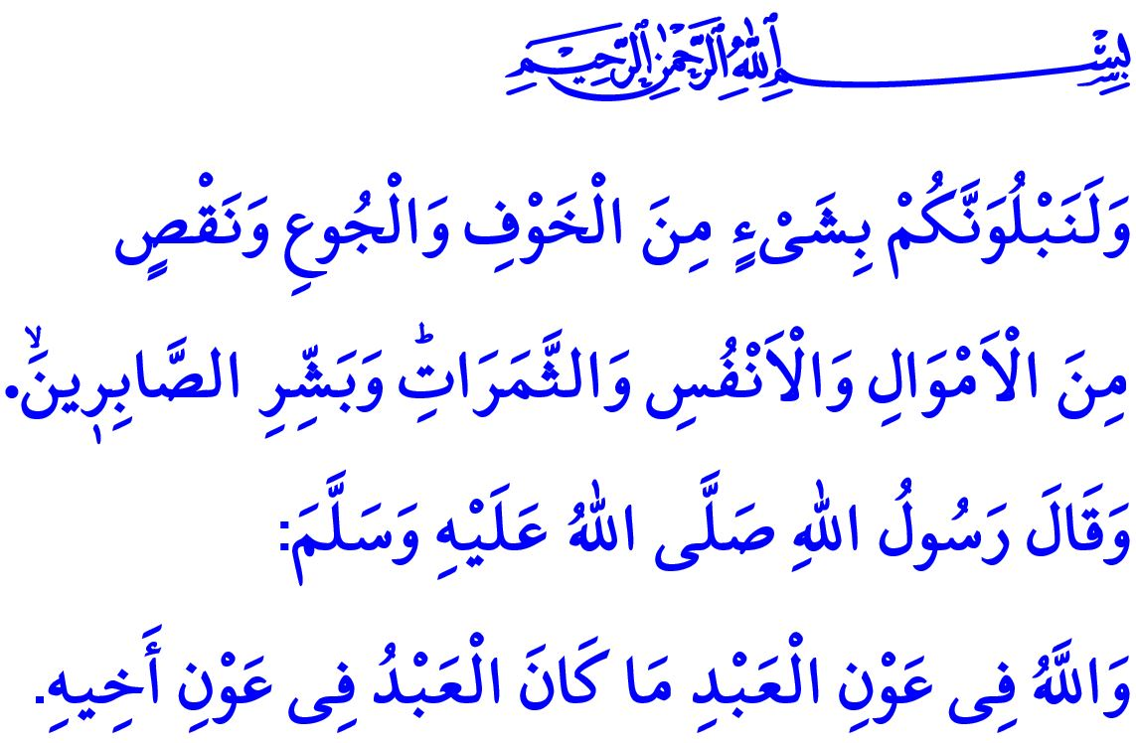
FOSTERING A GREATER AWARENESS OF NATURAL DISASTERS
Honorable Muslims!
A powerful earthquake hit our country last week. The sorrow and pain it caused broke our hearts. Tens of our brothers and sisters lost their lives. We all rushed for those people who got injured and lost their homes. Once again we came face to face with the reality of natural disasters. We all wish the Almighty Allah's mercy upon our brothers and sisters who lost their lives in this calamitous event, may He grant their families and loved ones with the best of patience. May He bless the injured with a speedy recovery. May He enable the victims of the earthquake to recover, get better, and hold on to life soon. May He protect our people from such natural disasters.
Dear Believers!
The universe runs in an order based on the divine laws and rules called "Sunnat al-Allah". The Almighty Allah has put these laws in place with His omnipotent power and knowledge. Earth, air, water, and fire each has its specific nature and balance. People need to live in such a way as to protect such nature and balance.
Earthquakes, too, happen in accordance with the divine laws. People are not able to prevent earthquakes, nor are they able to change their time and magnitude. They can, however, take certain measures not to get harmed in them. Only by taking necessary measures is it possible to minimize the loss of life and property caused by natural disasters such as earthquakes, floods, and fires.
Dear Muslims!
The Almighty Allah states in the Holy Qur'an, "We will surely test you with something of fear and hunger and a loss of wealth and lives and fruits. Give good tidings to the patient!" Muslims, then, live in the know that they will face various troubles in this world of tests and trials. They are aware of their limits and incapabilities, and are, as servants of Allah, in need of Him. They make every effort practicably possible to endure the troubles to come their way. They use their mind, knowledge, and experience, and take necessary precautions. Thereafter, they submit themselves to and rely on Allah (swt), as required by the iman they have. Even stronger than before, they come out of the troubles they are hit by through patience. They pass the divine test and trial by showing gratitude for the blessings and patience for the hardships. Prophet Muhammad (saw) describes this situation of Muslims as, "How wonderful is the case of a believer; there is good for him in everything and this applies only to a believer. If prosperity attends him, he expresses gratitude to Allah and that is good for him; and if adversity befalls him, he endures it patiently and that is better for him."
Dear Believers!
What suits a Muslim is to have a sense of responsibility against natural disasters. What Allah (swt) has ordained is meant to happen; and, what falls upon us is to take necessary measures and rely on Him. In this respect, Prophet Muhammad (saw) describes the stance Muslims should have against troubles, "Allah dislikes negligence and idleness. You should behave reasonably. However, once there is nothing left that you can do, then say, 'Sufficient is Allah for me. He is the Best Disposer of affairs.'"
So, let us draw lessons from bitter experiences. Let us all get prepared against natural disasters for a safe and secure life. Let us make right and proper moves in accordance with the balances of the nature and the realities of the region we live in. Let us inform our family members on disasters and emergencies.
Dear Muslims!
Alhamdulillah, today, too, just as in the past, we heal our wounds together as a nation regardless of differences in faith, sects, ethnic origins, and ideologies. It is never enough to express our appreciation for the support of our state and the solidarity of our nation. Our noble, sacrificing, and generous nation are thankfully the addressee of the good news given by the Prophet Muhammad (saw), "Allah will help His slave so long as His slave helps his brother."

Baqarah, 2/155.
Muslim, Zuhd, 64.
Abu Dawud, Aqdiyya, 28.
Abu Dawud, Adab, 60. General Directorate of Religious Services

